08
Fall
June
08


Cyclone Nargis: Lessons and implications for ICTs in Humanitarian Aid
Sanjana Hattotuwa

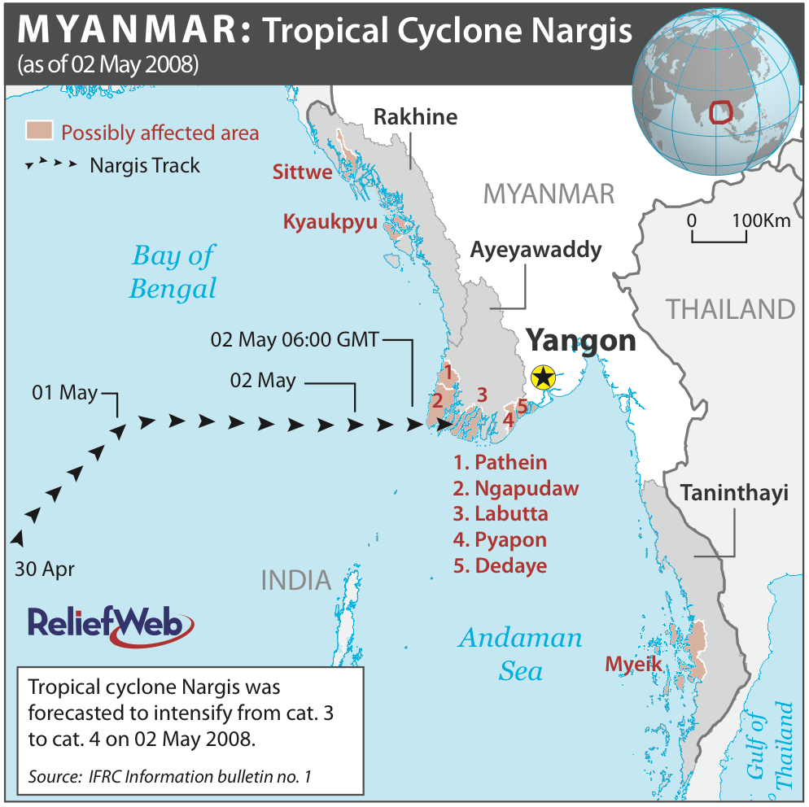

Cyclone Nargis: Lessons and implications for ICT4Peace

Table of contents

Cyclone Nargis: Background 4
Cyclone Nargis and the ICT4Peace Foundation 4
Salient points from media monitoring – 4 May to 25 May 2008 5
Case study of collaboration and coordination (INSTEDD Sahana localisation) 9
Communications and collaboration in general 10
Best business practices 11
Existing recommendations and best practices 12
Annex 1: The trail of devastation 17
Annex 2: Media monitoring – 4th May to 25th May 2008 19
Websites and resources 34

Cyclone Nargis: Background
Cyclone Nargis was a strong tropical cyclone that caused the deadliest natural disaster in the recorded history of Burma (officially known as Myanmar). The cyclone made landfall in the country on 2 May 2008, causing catastrophic destruction and at least 133,000+ fatalities, over 2.5 million internally displaced with tens of thousands still missing and feared dead.
Cyclone Nargis developed in the Bay of Bengal during the week 28 April to 2 May. It made landfall on 2 May as a Category 3 cyclone in the Irrawaddy delta region, approximately 250 km southwest of Rangoon. The storm then tracked inland, directly hitting the capital itself late the same night. Atypically, the storm did not dissipate over land significantly, and was still at Category 2-3 when it hit the capital. Much of the damage in the Irrawaddy delta was caused by a 3.6m storm surge.
Damage is estimated at over $10 billion (USD), which made it the most damaging cyclone ever recorded in this basin. It was also Burma's worst natural disaster overall, as well as being the deadliest. Relief efforts were slowed for political reasons as Burma's military rulers initially resisted aid. Burma's ruling party finally accepted aid a few days later from the U.S after India's request was accepted. Further hampering the relief effort was the unfortunate fact that only ten days after the cyclone nearby central China was hit by a massive earthquake, known as the Sichuan earthquake that measured 7.9 in magnitude and itself is projected to have taken nearly 50,000 lives. The trail of devastation can be found on Annex 1.

Cyclone Nargis and the ICT4Peace Foundation
Soon after the cyclone hit and it because increasingly evident that the damage to life and property far exceeded initial estimates the ICT4Peace Foundation Chairman, Daniel Stuaffacher, was copied to a spate of emails that included authors from inter-governmental, non-governmental, private business and commercial organisations, academia, former field level practitioners and others on how best to respond to the monumental challenges of information and communications technology provision to support the humanitarian operations. Eric Rasmussen from INSTEDD instigated the discussions. Many voices in the responses were familiar to the ICT4Peace Foundation from interactions in San Diego during the Strong Angel III.
It is noteworthy that the ICT4Peace Foundation and Daniel in particular were looked upon as being capable of giving impartial and critical advice on the on-going discussions on how best to provision ICTs to the support efforts.
Cyclone Nargis and its aftermath quite clearly fits into the Foundation’s current focus on crisis management. As noted on its website, crisis management is defined - for the purposes of the on-going stocktaking exercise with the United Nations, New York on crisis information management best practices - as civilian and/or military intervention in a crisis that may be a violent or non-violent with the intention of preventing a further escalation of the crisis and facilitating its resolution. In order to bridge the fragmentation between various organizations and actors during different phases of crises, ICT4Peace promotes holistic, cohesive and collaborative mechanisms directly in line with Paragraph 36 of the WSIS Tunis Commitment:
“36. We value the potential of ICTs to promote peace and to prevent conflict which, inter alia, negatively affects achieving development goals. ICTs can be used for identifying conflict situations through early-warning systems preventing conflicts, promoting their peaceful resolution, supporting humanitarian action, including protection of civilians in armed conflicts, facilitating peacekeeping missions, and assisting post conflict peace-building and reconstruction.”
ICT4Peace raises awareness about the Tunis Commitment and promotes its practical realization in all stages of crisis management.
In this case, guidance was primarily requested on identifying and harmonising the urgent needs of the first response and the various assets that respondents knew of, had access to and were willing to provide – for free, at cost or in an unspecified manner. The specific request for input into a multi-stakeholder information and communications requirements analysis, provisioning framework and implementation guidelines was by some respondents in the email group who felt that a wholly US generated model / approach would “likely create insurmountable problems upon arriving on the ground and further chaos”.
It is unclear and unknown to the author as to whether the Foundation issued any official communication on this matter to the group of concerned individuals that constituted the respondent to the (closed) network of Eric Rasmussen’s initial email. Internally, discussions on the matter engaged with Maria Cattaui, Alain Modoux, Barbara Weekes, Nigel Snoad and the author. Members of the Board were interested in formulating guidelines for the use of the group that had asked for Daniel’s input. They suggested that the Foundation could act as an “observer” and incorporate the lessons identified and learnt during the Nargis response into our own work in the future. It was not very clear to the Board as to what the Foundation could do practically, but it was emphasised that helping shape the responses to events of this nature from the International Community (IC) and transnational non-governmental actors, aid agencies and donors was precisely why the Foundation was set up and exists.
A sense of caution driven by the need to be impartial and constructively critical was articulated by Daniel Stauffacher, who noted that well meaning yet possibly vendor driven initiatives may run the risk of being detrimental to the larger response. Daniel noted on 14 May 2008 that “…we as a Foundation should not rush into operational trials at this stage, which could backfire and jeopardise our independence and reputation. However along with Alain [Daniel] proposed that we spend most of our ICT4Peace Board meeting to discuss our experiences and potential future approaches on how to address this issue.”
In the same email it was proposed that the Foundation prepares a short paper describing the technical, operational and political issues, considerations and possible solutions as they have been proposed in the past with regards to information and communications provisioning in disaster response with emphasis on the Burma experience as it unfolds.
This brief paper is the result of these discussions. It aims to very succinctly draw out vital considerations arising out of the Nargis response and how the Foundation can provide meaningful input into the current relief efforts as well as similar disasters in the future.

Salient points from media monitoring – 4 May to 25 May 2008
In order to ascertain the terrain of the dialogue on processes and events after Cyclone Nargis hit Burma on 2 May 2008 the author undertook a media monitoring exercise of all wire reports, aid agency updates, UN statements (esp. from the SG’s office) and other public announcements by news agencies as catalogued on ReliefWeb. The salient excerpts are to be found in Annex 2 and make for interesting reading.
Notable points, concerns and questions that arise from this media monitoring exercise are, inter alia and in no particular order:
- Lack of any mention of communications and information provisioning to support the relief efforts on the ground
Save for a single press release by the ITU on 16 May 2008, there is little or no mention of the need for an information and communications backbone for the relief efforts on the ground. If one were to assume that such a backbone was necessary for the coordination and collaboration of aid in a country were such infrastructure was rudimentary and unreliable at best, it is telling that emphasis was on power and lift logistics more than information and knowledge management. It was repeatedly noted in many stories that needs on the ground were unclear because domestic telephony was severely disrupted. This made it clear that the pre-Nargis humanitarian work in the country was almost wholly reliant on in-country telecoms architecture that post-Nargis were severely disrupted or rendered wholly inoperative. As noted, the only mention of any kind of ICT provisioning in the news stories monitored was the following paragraph that appeared through an ITU Press Release on 16 May 2008:
The International Telecommunication Union has deployed 100 satellite terminals to help restore vital communication links in the aftermath of Cyclone Nargis that hit Myanmar on 2 May with devastating effect in Yangon and the low-lying Irrawaddy delta region. The rapid deployment was made possible under the ITU Framework for Cooperation in Emergencies. ITU is providing both Thuraya hand-held satellite phones and Inmarsat Global Area Network (GAN) terminals. The Thuraya satellite phones use both satellite and GSM networks and also provide accurate GPS positioning coordinates to aid relief and rescue. The Inmarsat GAN terminals are mainly used for voice communications and, for high-speed data. ITU pays for all expenses, including transportation of the equipment and usage.
No mention of any of the advanced and rapidly deployable (proven and unproven) information and communications devices, mechanisms, tools and services that were talked about in the email group that responded to Eric Rasmussen’s call for ideas. There was also no further information reported as to who exactly was using, or able to use, the ICTs provisioned by the ITU.
- Little emphasis on collaboration and coordination of aid and relief efforts
None of the stories flagged the need for or existence of coordination and collaboration between the multi-national multi-stakeholder relief efforts as they unfolded and evolved in the days after Cyclone Nargis. Reporting concentrated on the individual aid / relief efforts of governments, regional bodies and aid agencies (UN and others). There was no emphasis and analysis on any mechanism or institution to coordinate the relief efforts in Burma or in staging areas in the region and elsewhere. Stories repeatedly noted that the central logistical problem was for relief and supplies to be channelled to the worst affected areas of the Irrawaddy delta from Yangon, Burma’s capital. Yet not a single story mentioned collaborative mechanisms between aid agencies and / or between aid agencies and the junta that facilitated this. Only a few news reports quoted UN officials on the need for collaboration between the various UN agencies.
The only concrete mention of collaboration / coordination in the relief effort was tellingly from ASEAN, which on 19 May after a special meeting of Foreign Ministers issued this statement:
“… the Ministers agreed to establish a Task Force, to be headed by ASEAN Secretary-General Surin Pitsuwan, which will work closely with the UN as well as a central coordinating body to be set up by Myanmar, to realize this ASEAN-led mechanism. The meeting agreed that this ASEAN-led approach was the best way forward.” (emphasis mine)
- ASEAN / Asian approach vs. Western powers and R2P
Many stories on the approach to the relief efforts by the French and German governments in particular suggested that they were more in favour of using the UN’s Responsibility to Protect (R2P) framework and the Security Council as a measure to overcome the significant barriers posed by the Burmese junta to effective relief and aid work. Governments such as India and China and those who constitute the members of ASEAN (of which Burma is a member) reportedly took a different tact – choosing engagement over threats, quiet diplomacy leveraging years of trust building with a xenophobic regime and choosing instead in the manner of expression to couch growing frustration in the appreciation of small measures of progress.
The United Nations recognised in 2005 the concept "responsibility to protect" civilians when their governments could or would not do it, even if this meant intervention that violated national sovereignty. Further, under international law, the 2 million or so people thought to have been made homeless by the cyclone are considered internally displaced. Under the UN Guiding Principles on Internal Displacement, a state should not arbitrarily withhold permission for international humanitarian organizations and other appropriate actors to provide aid, “particularly when authorities concerned are unable or unwilling to provide the required humanitarian assistance.” The principles further state that “All authorities concerned shall grant and facilitate the free passage of humanitarian assistance and grant persons engaged in the provision of such assistance rapid and unimpeded access to the internally displaced.”
It is evident that the junta was seemingly more partial to the ASEAN response over Western aid including that of the UN (it repeatedly impounded planes from the WFP and until the breakthrough agreement with the UN SG on 24 May 2008 severely restricted the granting of VISA’s to aid personnel) and had a schizophrenic attitude towards the aid offers in general – granting access to aid in an ad hoc manner. In general though, the call to go through the Security Council was in effect rebutted by OCHA itself.
This is a vexed and complex issue beyond the limited scope of this paper, but one that is clear through the media monitoring deeply influences the nature of and more importantly, the perception of relief efforts governed by a regime suspicious of foreign intervention in whatever capacity. It is also linked to the concerns expressed by Doug Hanchard noted earlier in this paper, where the statements of governments are conflated with the (often wholly independent) initiatives of aid agencies. Interesting to record here is that according to news reports, though the World Bank refused to give any money to Burma, it was nevertheless part of the ASEAN Emergency Rapid Assessment Team recommendation to set up the Humanitarian Coalition for the Victims of Cyclone Nargis (along with UN OCHA). Very early on as well, even the UN acknowledged that Asian staff were better able to get VISA’s than others.
- UN essential and seen as essential
Statements of the UN Secretary General, interventions by OCHA’s head honcho John Holmes and the significant pressure mounted by the UN’s various relief agencies were measured in their criticism, expressing significant and growing frustration at the junta’s approach to aid in a manner that was as diplomatic as possible. Reading through the lines the censure was evident, but when compared to the statements of individual governments such as the US, France, Germany and Australia (that did not shy away from calling the junta to be criminal in negligence to facilitate aid to the victims of Nargis) they were tethered to the overarching interests of access to aid flows and less with the politics of the Burmese junta. Interestingly, the critiques of Amnesty International, Human Rights Watch and the Asian Human Rights Commission (AHRC) over period monitoring were much more censorious of the junta than any of the statements of the UN SG or coming from the spokespersons of the UN agencies. Though the junta impounded airplanes from WFP and forcing it on 9 May to suspend its limited air operations into the country, did not respond to calls from the UN SG before his face to face meetings and blocked VISA’s to UN aid personnel, it was publicly appreciative of aid efforts by the UN and never once accused the institution or any of its constituent members of a hidden agenda. On the other hand, on 21 May the State media said that the juna would not accept cyclone aid carried by US naval ships because the relief supplies come with 'strings attached'.
It must also be placed on record that despite all threats to take recourse to Security Council action and R2P, it was the UN SG who was able to finally secure access to aid workers and more open relief channels into the country after meetings with the junta on 23 May 2008.
- The lack of any confirmed statistics on needs on the ground
Few were aware of exact ground conditions, including all UN agencies, for over a week after Nargis hit Burma. Many reports quote two sets of figures – one from the junta and published in State media, the other estimates and educated guesses of aid agencies located outside the country. Notable here is to record that on 4 May, a highly placed UN official went on record as saying that "There does not seem to be a high number of casualties but for sure there is a lot of damage to property and infrastructure". This shows the extent to which nothing was really known about the worst hit areas for days and even a week after the cyclone, information from the ground was sporadic, unreliable and oftentimes conflicting.
Reading through the news stories and the data conflicts, it is not clear as to whether information on the ground situation was being shared between actors involved in the relief efforts. No mention is made of information and knowledge sharing and there are many individual Who/What/Where reports by UN agencies and other relief agencies (e.g. DFID / Save the Children / Care International) that give varying figures of fatalities and those affected by Nargis.
Clearly, no one was relying on the statistics provided by the junta. Yet it was also clear that the UN and other aid agencies weren’t exactly collaborating in terms of needs assessments – with agencies issuing press releases with needs on the ground that were on occasion at some variance with the UN, which were both unsurprisingly different to what the military junta said.
- Statement of Mrs. Bush on early warning and its implications for aid and relief
As reported in the media, on 6 May First Lady of the US Laura Bush, who rarely speaks on foreign policy but has previously been vocal on Mynamar, criticised Yangon for failing to give its citizens adequate warning about the storm. "Although they were aware of the threat, Burma's state-run media failed to issue a timely warning to citizens in the storm's path," she said. News reports do not mention any aid agency’s response to that statement – positive or negative. On the other hand, some reports were openly critical. ‘The US first lady’s political demands were inappropriate,’ said Aung Naing Oo, an exiled Burmese political analyst. ‘This is a time when people are dying and suffering to a horrible degree, so if the US really wants to help, it can help without making political demands,’ he said. Aung Naing Oo suggested that the US might get no response from the junta due to Mrs Bush’s demands. ‘She might get nothing in return,’ he said. Further, Australian Foreign Minister Stephen Smith said that the international community should focus on humanitarian aid to Burma instead of criticizing the ruling junta's handling of the deadly cyclone. His comments came a day after the US first lady’s press conference.
Overall, news reports on the response to Nargis make for depressing reading. The nature of the junta and its prevention of vital aid, the fact that many victims were children and that many at greatest risk of morbidity post-Nargis were also children and the irascible demands placed on relief work with no overarching political agenda such as that which was proposed by the UN make for a context which is sui generis – a catastrophic disaster where relief efforts were completely hostage to the arbitrary decisions of a military junta impervious to the suffering of victims and international pressure.

Case study of collaboration and coordination (INSTEDD Sahana localisation)
Sahana is an integrated set of pluggable, web based disaster management applications that provide solutions to large-scale humanitarian problems in the aftermath of a disaster. The Sahana Free and Open Source Disaster Management System was conceived during the 2004 Sri Lanka tsunami. The system was developed to help manage the disaster and was deployed by a government's Centre of National Operations (CNO), which included the Centre of Humanitarian Agencies (CHA). Based on the success of this initial application and the dire need for good disaster management solutions, particularly to handle large-scale disasters, Swedish International Development Agency (SIDA) funded a second phase through LSF (Lanka Software Foundation) to generalize the application for global use and to help in any large-scale disaster. The project has now grown to become globally recognized, with deployments in many other disasters such as the Asian Quake in Pakistan (2005), Southern Leyte Mudslide Disaster in Philippines (2006) and the Jogjarkata Earthquake in Indonesia (2006). The phase II funded by SIDA did much to foster the capability of the project and the global community, now 170+ strong around it.
In an effort to help the inter-agency relief efforts, INSTEDD set up Sahana and began to localise it into Burmese. What follows are its own experiences with multi-stakeholder, cross-national collaboration to deal with an urgent need. Following are excerpts from the blog entries of the Eduardo Jezinski, the Director of Engineering at INSTEDD.
- There are over 30 volunteers across 4 continents working on localizing Sahana to Burmese. We ran into multiple issues, most stemming from the lack of Unicode standardization of Burmese.
- We are using Google Spreadsheets to coordinate the work (the embedded live chat is an amazing feature for live coordination) and folks are using mostly MS Word to do the translations, which we accumulate on a Google Groups page.
- Set up Google Groups to coordinate translations - http://groups.google.com/group/sahana-localization/web/burmese-sahana-localization-for-myanmar-response
- Translation is hard - especially for the fonts and encodings to work together. One of the main issues with the localization is that it isn't just about translating strings - there is also a need to accept input in the right format. This isn't trivial with all combinations of fonts and input methods people use, and especially not trivial on a web page that has to work in multiple browsers!
- Our challenges were the need for fast coordination and high-bandwidth communication. We jumped onto Skype pretty often the first nights. It took time and false starts to figure out and describe the job well enough. I was ecstatic when the first translated line came in, and another one volunteers started explaining the task to other volunteers, and the speed picked up pretty fast.
- We used Google spreadsheets to co-edit the master list of all translation batches and get a live chat amongst all volunteers, without having to agree on any IM technology. That feature by itself was great as it gave a chance for volunteers to see each others' online status and ask questions of each other. Without it, we would have been caught in the middle brokering every conversation!
- The last 20% took a big chunk of the time. As we neared the end, minor issues on collisions and questions compounded with the 24-hour cycle of getting questions asked and answered from different sides of the planet.

Communications and collaboration in general
Myanmar, by the way, as a member of ASEAN, has signed the Agreement on Disaster Management and Early Response, and thereby has international commitments to uphold in regard to early warning networks, international cooperation and coordination, and relief and rehabilitation after humanitarian disasters. Article 7, Disaster Early Warning, says:
- The Parties shall, as appropriate, establish, maintain and periodically review national disaster early warning arrangements including:
- regular disaster risk assessment;
- early warning information systems;
- communication network for timely delivery of information; and
- public awareness and preparedness to act upon the early warning information.
- The Parties shall co-operate, as appropriate, to monitor hazards which have trans-boundary effects, to exchange information and to provide early warning information through appropriate arrangements.
It’s clearly a question as to whether Myanmar has met its commitments. Pertinent to the focus of this paper in particular are points 1(c) and 2. Some news reports indicate the junta was actually aware of the magnitude of Nargis as it was approaching the South Western coastline of Burma.
An analysis by researchers has revealed that Myanmar authorities could have had as much as 72 hours notice of the devastating Cyclone Nargis, which is now estimated to have claimed about 100,000 lives… According to the BBC, reports on Myanmar state television say warnings were issued on television and radio several days before the cyclone. Yet people in Myanmar say the severity of the cyclone was unclear and no instructions were given as to what action they should take, adds the BBC.

Best business practices
In an email dated 16 May 2008 Maria Cattaui, member of the ICT4Peace Foundation board articulated some thoughts on how best business could strengthen humanitarian aid in general. Expressing interest in “a good and disciplined approach with businesses” she noted that:
“I fully understand the problems and the difficulties that the UN / international / governmental world have in dealing with the business world. Let's try to make some sense of it and develop some guidelines. Businesses always appreciate clarity and consistency -- and appropriate / effective / efficient rules!”
This discussion was rendered vital because of the nature of the group that Eric Rasmussen first sent his email to, a collection of voices mostly involved in commercial enterprises or with a vested interest in one of more commercial technologies, tools and services they then sought to promote as appropriate for the Burmese relief efforts.
The author has dealt with some concerns and best practices in this regard stemming out of Strong Angel III at length. One of the best resources in this regard, and pre-figuring the discussions necessary to draw up the guidelines Maria points to is the Business engagement in humanitarian relief: key trends and policy implications report by Andrea Binder and Jan Martin Witte published by the Humanitarian Policy Group of the Overseas Development Institute (ODI).
Several key points and recommendations in this report bear emphasis in this paper.
- Partnerships with businesses can bring needed technical expertise and added capacity – but developing a strong working relationship takes time and effort. Past attempts to pursue partnerships with corporate agencies have often been frustrated as agencies are unclear about the intended outcomes for the partnership, or view it as a way of developing a long-term funding arrangement. Partner selection should be based on a match between identified gaps, the skills and capacities on offer and the ability of the agency to manage the partnership. Equally, companies should seek not to limit themselves to natural disasters or high-profile cases – positive image is based on credibility and, in the long run, responding to greatest need will contribute more to such credibility than opportunistic efforts. Finally, companies should be more transparent about the contributions they make to humanitarian relief. Research in this area is hampered by companies’ reluctance to provide privileged information, irrespective of whether their engagement is based on a commercial or non-commercial model.
- Traditional humanitarian actors and businesses should be aware of the limits of partnerships – they are by no means a panacea. For example, cooperation with private sector actors in humanitarian action will probably remain limited to natural disaster settings. Similarly, companies should not try to emulate what traditional humanitarian agencies have been doing for decades, but should aim instead to supplement these efforts with their particular corporate strengths. The case studies suggest that business engagement in humanitarian relief is most effective and sustainable when it builds on the core competences of the company.
- To establish themselves as accepted players in the humanitarian domain, companies will need to make a more coordinated effort to inform the public about their work. Government donors have to press for humanitarian relief that is most beneficial to those in need, irrespective of the legal status of the organisation providing it. Through systematic evaluations, government donors should determine where commercial providers – as they claim to do – can indeed generate more value for money without undermining humanitarian principles.
It would be interesting to extrapolate from these very interesting points lessons and recommendations specific to the ICT4Peace Foundation’s understanding of and approach to the involvement of commercial enterprise in aid and relief work, drawing upon the expertise of Maria and Dag Nielson as well as that of Nigel Snoad.

Existing recommendations and best practices
These are a collection of recommendations from various sources pertinent to the relief response in Burma but more generally to the Foundation’s approach to and understanding of impartially and critically evaluating relief and aid responses by other actors. The recommendations that follow are a mix of technical, operational, strategic, political, financial and logistical covering the areas of information and communications provisioning to the deployment of aid personnel and their interactions with domestic military actors, particularly resonant in the case of Burma.
In sum, all the recommendations call for a measure of restraint when foreign actors, especially Western actors, are involved in non-Western disaster response scenarios. There is an emphasis on leveraging local expertise, using sustainable technology, augmenting local capacities for reconstruction, building up local resilience to deal with future hazards and cautioning against the use of advanced technologies for communications without due recognition of spectrum interference caused by multiple signals in close proximity to each other (the bane of Strong Angel III).
- In addition to the material below, more best practices and recommendation and with a particular focus of civilian military relations can be found at Strong Angel III - Design considerations / recommendations for humanitarian aid systems (http://ict4peace.wordpress.com/2006/08/24/strong-angel-iii-design-consideration-for-humanitarian-aid-systems), Stability, Security, Transition and Reconstruction: Observations and Recommendations from the Field (http://ict4peace.wordpress.com/2006/11/08/sstr-observations-and-recommendations-from-the-field/), Soldiers and State-Building (http://ict4peace.wordpress.com/2007/04/07/soldiers-and-state-building/), Civil-Military Discussions at Strong Angel III (http://ict4peace.files.wordpress.com/2006/09/civ-mil-discussion-notes.pdf).
- More resources on Civilian Military coordination / collaboration - http://www.reliefweb.int/rw/lib.nsf/doc207?OpenForm&query=3&cat=Civil-Military%20Coordination
- Information and Technology Requirements Initiative: Assessment Report - Key Findings, Paul Currion, Emergency Capacity Building Project, Apr 2006 - http://www.reliefweb.int/rw/lib.nsf/db900SID/OCHA-6TG2P5?OpenDocument
- Best practices and lessons learnt in Information Management during crises - http://www.reliefweb.int/rw/lib.nsf/doc207?OpenForm&query=3&cat=Information%20Management
- Tampere Convention on the Provision of Telecommunication Resources for Disaster Mitigation and Relief Operations - http://www.reliefweb.int/rw/lib.nsf/db900SID/PANA-7CNCUM?OpenDocument
- Telecommunications in crises - http://www.reliefweb.int/rw/lib.nsf/doc207?OpenForm&query=3&cat=Telecommunications
Cyclone Nargis, Myanmar': ASEAN emergency rapid assessment team mission report, 09-18 May 2008 - http://www.reliefweb.int/rw/rwb.nsf/db900sid/LSGZ-7ESGDE?OpenDocument
- A 'Humanitarian Coalition for the Victims of Cyclone Nargis' is established immediately to coordinate and facilitate the ongoing relief, recovery and future reconstruction efforts. This should include ASEAN (including the Government of Myanmar), neighbouring countries to Myanmar, the United Nations and other international organisations beyond the region.
- The 'Humanitarian Coalition for the Victims of Cyclone Nargis' acts as a coordinating platform for relief and recovery strategies and be expanded to involve key partners who will enhance coordination and information sharing.
- The 'Humanitarian Coalition for the Victims of Cyclone Nargis' establishes a mechanism in partnership with the Government of Myanmar for access of coalition partners to implement urgent relief and recovery programmes in cyclone affected areas.
- The implementation of the 'Humanitarian Coalition for the Victims of Cyclone Nargis' should commence with the establishment of a task force comprising representatives from the Government of Myanmar, ASEAN Secretariat, UNOCHA and key international organisations.
- Experienced assessment teams in partnership with the Government of Myanmar will complete further detailed assessments and analyses of the current situation in the entire affected area.
- The 'Humanitarian Coalition for the Victims of Cyclone Nargis' along with the Government of Myanmar will develop a plan of action and subsequent activities to meet its goals in line with assessments from the field, with a focus on priority needs.
- Disaster risk reduction strategies are incorporated in planning to ensure a policy of 'build back better' is employed in relation to schools, hospitals, other public buildings and housing.
- The capacity of the Government and people of Myanmar be enhanced through this partnership and through inclusion and training in well established mechanisms such as the ACDM, UNDAC, International Search and Rescue Advisory Group (INSARAG) and the Environmental Emergencies Network.
Recommendations of Strong Angell III: Lessons learnt - https://www.hlforum.com/briefings/HF_10-06_mini/10-06_mini-execsummary.htm
- Integrate your capabilities with those already on the ground. In humanitarian assistance and disaster response (HA/DR) operations, local groups as well as members of nongovernmental organizations (NGOs), international organizations (IOs), and United Nations (UN) agencies often are on the ground long before a U.S. military contingent arrives to lend support. It is important that those arriving later in the response integrate their tools with existing functional systems, and not seek to impose their own way of doing things. ReliefWeb and the UN's Virtual On-Site Operations Coordination Center (OSOCC), for example, are both functional platforms that can form a basis for ongoing collaboration.
- Centralized information systems hinder inter-organizational coordination, because the latter requires processes. Meshes are a more accurate way of modeling real-world information flows, and architectures should be designed accordingly. If possible, tools should be developed in the field with those who actually will be using them. This means that mashups will inevitably be more effective than tools requiring long development cycles. Strong Angel III saw Microsoft working with Google, and more than a dozen geographic information systems (GIS) groups putting aside their commercial rivalries to develop a common mapping system. These were both unprecedented events. The demonstration also showcased systems such as TOOzL (The One-Ounce Laptop), comprising a suite of free, open source software tools on a USB drive, designed to provide all of the functionality required to coordinate an effective informatics response anywhere in the world.
- In the fog of SSTR and HADR operations, do not lose sight of the people you are helping. Often those who are in need do not have a voice in their own recovery, and this is counterproductive. It is important to provide assistance without displacing the natural economies of all kinds that exist locally. The solution to any country's problems usually lies in combining existing (local) elements in different ways – rather than in introducing new (foreign) elements. In addition, all military units must understand and be familiar with the 1994 Oslo Guidelines (Guidelines on the Use of Military and Civil Defense Assets in Disaster Relief), which detail how military groups will interact with nonmilitary players. Ignoring the Guidelines – whether inadvertently or deliberately – can reflect very badly on the organizations involved.
- Within integrated operations, Wi-Fi should not be on the critical path for communications. This is controversial but supported by experience both at Strong Angel and in the field. When there is no common authority, differing agendas, and varied donors, and all involved are working under stressful conditions, the end result is that everyone crashes because everybody usurps everybody else's bandwidth. If every player shows up with a personal wireless transmitter, then no one will be able to get a signal out. As alternatives, GSM chips (Global System for Mobile Communications) work well, enabling communications through Short Message Service (SMS), for example. High-frequency (HF) email run by amateur ("ham") radio operators is another option and was one of the salient success stories of Strong Angel III.
- To be effective in HA/DR environments, technologies must be commercial, off-the-shelf (COTS); open source; and deployable using open standards. Field tools that are simple, flexible, robust, redundant, and used routinely – such as Sahana, the Sri Lankan disaster management tool – are those that will succeed. User productivity is more relevant than throughput, and product testing should be focused accordingly. COTS technologies that were invaluable at Strong Angel III included Aqua Genesis' Delta T desalination device; General Motors' (GM's) hybrid disaster truck, with outlets throughout the bed of the truck; PowerFilm's flexible solar panels; SkyBuilt Power's mobile power station (MPS); Ground Antenna Transmit and Receive (GATR) Technologies' inflatable VSAT (very small aperture terminal) communications antenna, a.k.a. the "beach ball satellite dish"; "hexayurts", built entirely on-site with basic materials such as fiberglass boards and duct tape; Microsoft's Smart Personal Object Technology (SPOT) watches (discreet FM radio broadcasting technology); and VSee Labs low-bandwidth and low-latency video teleconferencing (VTC) equipment.
- Subject matter experts are key to an effective response. Much of the information that we need in a crisis is information that somebody already has; but that person is not necessarily someone we know. Common citizens also have specialized skills and local knowledge that can be invaluable to a HA/DR or SSTR operation. So how do we access that tacit knowledge? Social networks do not spontaneously flourish in the middle of a crisis; they are built up and sustained over a long period of time, and they vary depending on the situation. In a crisis, organizations are thrown together very suddenly, and they have very little visibility either within their own organization or into others. The ability to traverse those networks quickly is essential. It requires bringing in new people as well as capturing the wisdom and skills of those who have already left. Batchtags is an example of a tool that can help us build networks before an event, identify knowledge during an event, and incorporate local wisdom. It is simple to use, editable, and has the auditability of a wiki; it incorporates reputation, traceability, and accountability.
- Restoring trust and momentum in failed states is the only path to reconstruction. The new interactions between networks, the market, and hierarchical forms of government are fundamentally changing the world. This means that the nature of SSTR operations and aid to failed states also is evolving. Ashraf Ghani and Clare Lockhart's Framework for State-Effectiveness helps project some clarity into the confusion and complexity that comes with aiding a destroyed nation. It is a pragmatic development from the bottom up of how to rebuild trust between a government and its people, predicated on the specific functions that a state should perform for its citizens – political, social, economic, and legal. Restoring trust as an outside party means carrying out cultural due diligence to understand both what is important and what is potentially threatening in the local culture. Small gestures of cultural understanding towards a host nation can make a significant difference, whereas the appearance of "not caring" is damaging. Trust also means keeping promises: if a local community is told that it will be getting a functional hospital, for example, and in fact that hospital remains unsanitary and dysfunctional, local conditions are likely to degenerate, not improve.
- We must continue to improve our capacity to share information with "non-traditional" partners. There are two main challenges: first, finding mechanisms to more rapidly declassify or desensitize information that is critical to a humanitarian response; and second, enabling more rapid and effective sharing and dissemination of unclassified information. Caveats such as FOUO (For Official Use Only) should be avoided wherever possible. Examples include the ability to share maps in Iraq with contractors and NGOs for the purpose of road reconstruction, and the ability to desensitize surveillance tapes in Indonesia – by removing the encoding – to help the UN agencies coordinate aircraft landing clearances and locations. Sometimes this information is not sharable even with other U.S. Government (USG) agencies such as the Agency for International Development (USAID); this is a serious problem. The United States Joint Forces Command (USJFCOM) was commended by several participants for taking strong steps in the direction of sharing of unclassified information.
- Several USG policies should be reconsidered in order to bolster the effectiveness of HA/DR operations. Three areas in particular were emphasized at this session: first, the need to amend funding and acquisition cycles in order to enable the deployment of people and funds within days or weeks, rather than months. Viable HA/DR operations require reliable funding as well as operational independence. Second, the need to enable military organizations to "leave a place better than they found it", i.e., to not remove all of their equipment when they return home. Some progress is being seen here, with new legislation enabling certain forms of information and communications technologies (ICTs) to be left behind by U.S. military units. And third, the need to enable the assignment and deployment of those individuals in both government and the private sector with critical subject matter expertise, particularly at the intersection of humanitarian relief and information technology. Currently, both organizational and political hurdles impede such deployments.
Global Symposium +5: Information for Humanitarian Action, Geneva, 22-26 October 2007, Final Statement, Version 0.8 – 30 November 2007 - http://www.reliefweb.int/symposium/docs/Symposium%20Final%20Statement.pdf
Principles of Humanitarian Information Management and Exchange
- Accessibility. Humanitarian information and data should be made accessible to all humanitarian actors by applying easy-to-use formats and by translating information into common or local languages. Information and data for humanitarian purposes should be made widely available through a variety of online and offline distribution channels including the media.
- Inclusiveness. Information management and exchange should be based on collaboration, partnership and sharing with a high degree of participation and ownership by multiple stakeholders including national and local governments, and especially affected communities whose information needs should equally be taken into account.
- Inter-operability. All sharable data and information should be made available in formats that can be easily retrieved, shared and used by humanitarian organizations.
- Accountability. Information providers should be responsible to their partners and stakeholders for the content they publish and disseminate.
- Verifiability. Information should be accurate, consistent and based on sound methodologies, validated by external sources, and analyzed within the proper contextual framework.
- Relevance. Information should be practical, flexible, responsive, and driven by operational needs in support of decision-making throughout all phases of a crisis. Data that is not relevant should not be collected
- Impartiality. Information managers should consult a variety of sources when collecting and analyzing information so as to provide varied and balanced perspectives for addressing problems and recommending solutions.
- Humanity. Information should never be used to distort, to mislead or to cause harm to affected or at risk populations and should respect the dignity of victims.
- Timeliness. Humanitarian information should be collected, analyzed and disseminated efficiently, and must be kept current.
- Sustainability. Humanitarian information and data should be preserved, cataloged and archived, so that it can be retrieved for future use, such as for preparedness, analysis, lessons learned and evaluation. The use of Open Source Software should be promoted to further enhance access to information by all stakeholders in a sustainable way. When possible, post emergency data should be transitioned to relevant recovery actors and host governments and training provided on its use.
- NEW PRINCIPLE: Reliability. Users must be able to evaluate the reliability and credibility of data and information by knowing its source and method of collection. Collection methods should adhere to global standards where they exist to support and reinforce credibility. Reliability is a prerequisite for ensuring validity and verifiability.
- NEW PRINCIPLE: Reciprocity. Information exchange should be a beneficial two-way process between the affected communities and the humanitarian community, including affected governments.
- NEW PRINCIPLE: Confidentiality. The processing of any personal data shall not be done without the prior explicit description of its purpose and will only be done for that purpose, and after prior informed consent of the individual concerned. Sufficient safeguards must be put in place to protect personal data against loss, unauthorized processing and other misuse. If sensitive information is publicly disclosed, the sources of such information will not be released when there is a reasonable risk that doing so will affect the security or integrity of these sources.

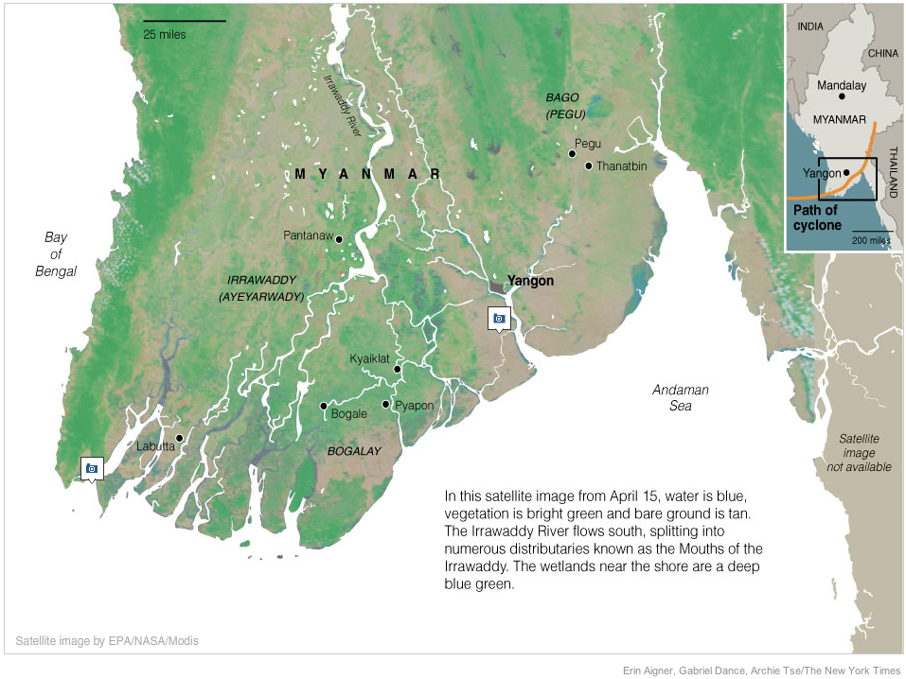
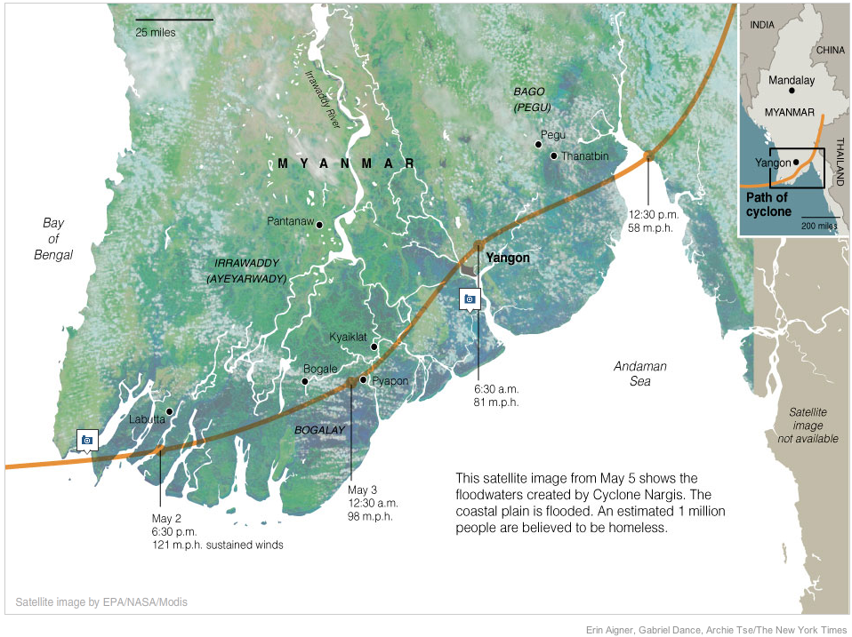
Annex 1: The trail of devastation
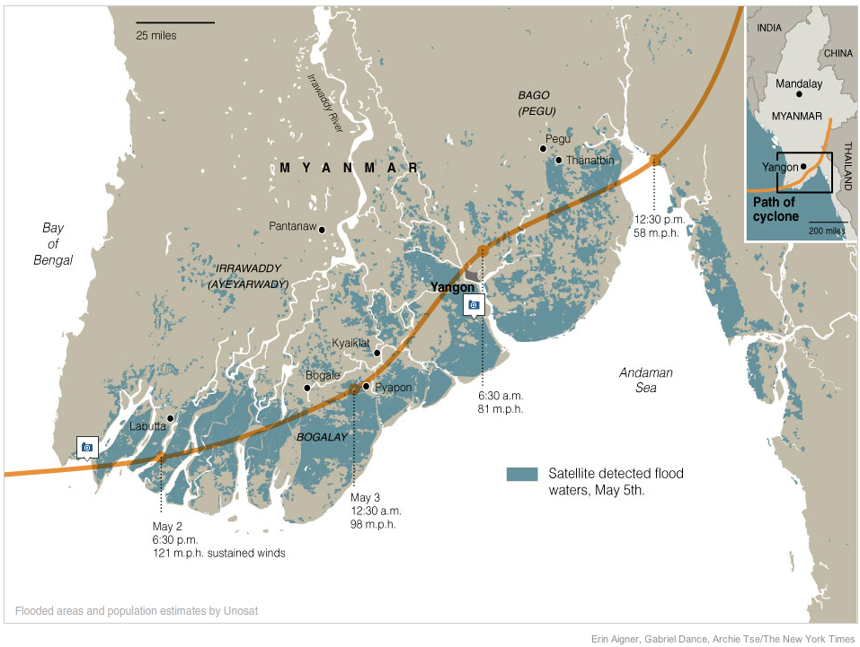
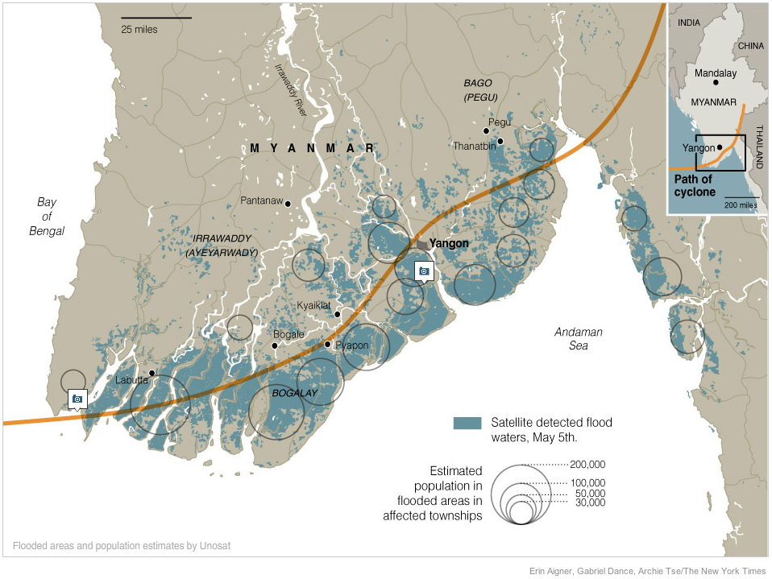

Annex 2: Media monitoring – 4th May to 25th May 2008

Date / Source | URL / Description
4 May 2008 | http://www.reliefweb.int/rw/rwb.nsf/db900sid/KKAA-7EB9EU?OpenDocument&rc=3&emid=TC-2008-000057-MMR  It will take several days to assess the scale of damage wrought by a large tropical cyclone that slammed into Myanmar's main city, Yangon, and outlying areas, a top U.N. official said on Sunday.  "There does not seem to be a high number of casualties but for sure there is a lot of damage to property and infrastructure," Therje Skavdal told Reuters in Bangkok. "It's early and it will take a few days before we get an overview of the damage," said Skavdal.
4 May 2008  IRIN | http://www.reliefweb.int/rw/rwb.nsf/db900sid/SNAO-7EBVNA?OpenDocument&rc=3&emid=TC-2008-000057-MMR  According to UN officials, the water supply is unfit to drink in the aftermath of the destruction, raising fears of water-borne diseases. Electricity is not working, landline communications are disrupted, mobile phone communications work sporadically, and radio and television networks are not operating. In addition, ocean storm surges of up to 12 feet (3.5 metres) are putting residents of coastal communities at high risk, meteorological officials said.
5 May 2008 | http://www.reliefweb.int/rw/rwb.nsf/db900sid/LRON-7ECBV7?OpenDocument&rc=3&emid=TC-2008-000057-MMR  "It's clear that this is a major disaster," Richard Horsey, of the United Nations disaster response office in Bangkok, told Reuters after an emergency aid meeting. "How many people are affected? We know that it's in the six figures. We know that it's several hundred thousand needing shelter and clean drinking water, but how many hundred thousand we just don't know," he said.
http://www.reliefweb.int/rw/rwb.nsf/db900sid/LRON-7ECDN3?OpenDocument&rc=3&emid=TC-2008-000057-MMR
Bunkered down in Naypyidaw, 240 miles to the north of Rangoon, the junta's top brass has not formerly responded to an offer of international assistance. But UN officials met with Burma's Minister of Social Welfare on Sunday "and the indication was assistance may be welcomed, but we need to understand the terms," Skavdal said. "I think it's a positive sign. As long as we are in dialogue it is good," he said. State media said on Monday that a referendum on a new army-drafted constitution would go ahead on May 10 despite the cyclone.
http://www.reliefweb.int/rw/rwb.nsf/db900sid/EGUA-7ECNGR?OpenDocument&rc=3&emid=TC-2008-000057-MMR
SG/SM/11545
The following statement was issued by the Spokesperson for UN Secretary-General Ban Ki-moon on 4 May:
The Secretary-General is deeply saddened by the loss of life and the destruction suffered by the people of Myanmar after Cyclone Nargis struck the country on 2 May. He extends his deepest condolences to the families of those who have been killed, injured or made homeless because of the storm.
As a first step, a United Nations Disaster Assessment and Coordination (UNDAC) has been organized and is on stand by to assist the Government in responding to humanitarian needs, if required.
The United Nations is also prepared to extend other necessary assistance and to mobilize international aid in support of the Government, if needed.
http://www.reliefweb.int/rw/rwb.nsf/db900sid/YSAR-7ECPRY?OpenDocument&rc=3&emid=TC-2008-000057-MMR
Myanmar's military junta believes at least 10,000 people died in a cyclone that ripped through the Irrawaddy delta, triggering a massive international aid response for the pariah state in southeast Asia. "The basic message was that they believe the provisional death toll was about 10,000 with 3,000 missing," a Yangon-based diplomat told Reuters in Bangkok, summarising a briefing from Foreign Minister Nyan Win. "It's a very serious toll.
The U.N. office in Yangon said there was an urgent need for plastic sheeting, water purification tablets, cooking equipment, mosquito nets, health kits and food. It said the situation outside Yangon was "critical, with shelter and safe water being the principal immediate needs."
"How many people are affected? We know that it's in the six figures," Richard Horsey, of the U.N. disaster response office, told Reuters after an emergency aid meeting in Bangkok on Monday before the state TV announcement. "We know that it's several hundred thousand needing shelter and clean drinking water, but how many hundred thousand we just don't know."
http://www.reliefweb.int/rw/rwb.nsf/db900sid/YSAR-7ECPUK?OpenDocument&rc=3&emid=TC-2008-000057-MMR
"It is senseless to conduct a referendum while people are filled with sorrow and worries," said Nyo Ohn Myint, the foreign affairs in-charge of the exiled National League for Democracy (Liberated Area). Calling the decision "inhuman," Nyo Ohn Myint said the ruling generals have no sympathy for the people, who are now struggling to re-build homes and finding ways to survive.
5 May 2008  Mercy Corps | Up to one million people could be homeless in Myanmar following the most devastating cyclone to hit Asia since 1991. On Tuesday, Myanmar's military government raised its death toll from last weekend's Cyclone Nargis to nearly 22,500, with another 41,000 missing.
http://www.reliefweb.int/rw/rwb.nsf/db900sid/KKAA-7ED4Y7?OpenDocument&rc=3&emid=TC-2008-000057-MMR
WORLD FOOD PROGRAMME SPOKESMAN IN BANGKOK:
"The government indicated willingness to accept international assistance through the U.N. agencies. I'd say it was a careful green light. The U.N. will begin preparing assistance now to be delivered and transported to Myanmar as quickly as possible."
INDIAN FOREIGN MINISTRY STATEMENT:
"In keeping with India's historical, close and good neighbourly ties with the friendly people of Myanmar, the government of India is providing immediate relief assistance.
"Two Indian naval ships ... will sail immediately to Yangon carrying food items, tents, blankets, clothing, medicines, etc."
U.S. STATE DEPARTMENT SPOKESMAN:
"We also have a disaster assistance response team that is standing by and ready to go in to Burma to help try to assess need there.
"My understanding was they had asked for permission but the initial response from the government was that they weren't inclined to let them in."
EU OFFICIAL ON EUROPEAN COMMISSION RESPONSE:
"The Commission is ready to provide humanitarian aid as quickly as possible once it has more information about the needs."
BRITISH FOREIGN OFFICE MINISTER, MEG MUNN:
"We call on the Burmese regime to provide rapid support to its people and to accept international assistance."
6 May 2008 | http://www.reliefweb.int/rw/rwb.nsf/db900sid/KKAA-7ED3TX?OpenDocument&rc=3&emid=TC-2008-000057-MMR  First Lady Bush, who rarely speaks on foreign policy but has previously been vocal on Mynamar, also criticised Yangon for failing to give its citizens adequate warning about the storm. "Although they were aware of the threat, Burma's state-run media failed to issue a timely warning to citizens in the storm's path," she said.
http://www.reliefweb.int/rw/rwb.nsf/db900sid/KKAA-7ED9MS?OpenDocument&rc=3&emid=TC-2008-000057-MMR
Cyclone Nargis and its aftermath in military-ruled Myanmar killed 15,000 people, including 10,000 in one town, Foreign Minister Nyan Win said on Tuesday.
Speaking on state-run television, Nyan Win indicated the toll could be higher as the government was still assessing damage in remote villages in the Irrawaddy delta area.
In addition, Nyan Win said 67 vessels and a few ferries along the rivers in the delta had sunk during the storm. A few harbors were destroyed.
He said the government welcomed all international assistance, adding the the most urgently needed equipment was:
- Tents
- Plastic sheets, bricks and zinc roofing sheets
- Household nails
- Medicine
- Instant food
- Clothes and blankets
- Communication equipment
http://www.reliefweb.int/rw/rwb.nsf/db900sid/AMMF-7EDFKS?OpenDocument&rc=3&emid=TC-2008-000057-MMR
UN aid agencies waited Tuesday for visas for disaster response teams to travel to cyclone-hit Myanmar Tuesday amid rebukes that an early warning system could have saved lives in the reclusive country.
http://www.reliefweb.int/rw/rwb.nsf/db900sid/STRI-7EDLWR?OpenDocument&rc=3&emid=TC-2008-000057-MMR
The Swiss Agency for Development and Cooperation (SDC) has released an initial funding package of CHF 500,000 for the victims of Cyclone Nargis in Myanmar, the Swiss Red Cross has set aside CHF 200,000.
http://www.reliefweb.int/rw/rwb.nsf/db900sid/ASIN-7EDQLU?OpenDocument&rc=3&emid=TC-2008-000057-MMR
‘The US first lady’s political demands were inappropriate,’ said Aung Naing Oo, an exiled Burmese political analyst. ‘This is a time when people are dying and suffering to a horrible degree, so if the US really wants to help, it can help without making political demands,’ he said.
Aung Naing Oo suggested that the US might get no response from the junta due to Mrs Bush’s demands. ‘She might get nothing in return,’ he said.
Australian Foreign Minister Stephen Smith said that the international community should focus on humanitarian aid to Burma instead of criticizing the ruling junta's handling of the deadly cyclone. His comments came a day after the US first lady’s press conference.
Washington has released an initial sum of US $250,000 toward the relief effort. However, Mrs Bush made it clear that any assistance would go through the United Nations or international non-governmental organizations—not directly to a regime under US sanctions for failing to embrace democratic reforms.
http://www.reliefweb.int/rw/rwb.nsf/db900sid/STRI-7EDSV8?OpenDocument&rc=3&emid=TC-2008-000057-MMR
In Bangkok, UN officials were waiting anxiously for visas so they could begin a potentially massive relief operation. "The OCHA [Office for the Coordination of Humanitarian Affairs] team has assembled in Bangkok and is ready to deploy as soon as possible," said Richard Horsey, a spokesman for the OCHA. "We are waiting for the green light on visas." "The major bottleneck will be the local delivery, rather than getting stuff in to the Rangoon [former name of Yangon] airport," Horsey said. "We need distribution channels."
7 May 2008 | http://www.reliefweb.int/rw/rwb.nsf/db900sid/KKAA-7EE5T8?OpenDocument&rc=3&emid=TC-2008-000057-MMR  "The major challenge is to figure out an exact assessment of the damage," says Jennifer Pagonis, a spokesperson for the United Nations High Commissioner for Refugees in Geneva. The disaster is compelling one of the world's most secretive and isolated regimes to swing open its doors to the international community. At a meeting with foreign diplomats on Monday, Burma's foreign minister Nyan Win appealed for international aid – a dramatic political reversal from 2004, when the junta rejected such assistance after the devastating tsunami.
http://www.reliefweb.int/rw/rwb.nsf/db900sid/LRON-7EEDZK?OpenDocument&rc=3&emid=TC-2008-000057-MMR
The United Nations said on Wednesday it had obtained permission to fly emergency supplies to cyclone-ravaged Myanmar but aid workers were still waiting for visas to enter the isolated country. "The government has given the authorisation to have the U.N. ship relief items to Myanmar," said Elisabeth Byrs, spokeswoman of the U.N. Office for the Coordination of Humanitarian Affairs. "They may also give authorisation to a small team from OCHA to accompany the relief flight," Byrs said, adding that the flight would leave "as soon as possible".
http://www.reliefweb.int/rw/rwb.nsf/db900sid/LRON-7EEG2F?OpenDocument&rc=3&emid=TC-2008-000057-MMR
International charity Save the Children said Myanmar authorities had given aid workers no word on when visas would be granted. "We have absolutely no idea of what progress, if any, will be made on better visa management," its Bangkok-based spokesman Dan Collinson told AFP, after a meeting of relief agencies at UN offices here. "We're frustrated. At the moment we still have a reasonable amount of capacity in-country, but that's going to run out very quickly," he said. "This issue is one of a number being raised at a high UN level. I think the maximum amount of pressure is being applied at the highest level of UN discussions."
http://www.reliefweb.int/rw/rwb.nsf/db900sid/LRON-7EEGUE?OpenDocument&rc=3&emid=TC-2008-000057-MMR
France has suggested invoking a U.N. "responsibility to protect" clause and delivering aid directly to cyclone-hit Myanmar without waiting for approval from the military in Rangoon, the foreign minister said. The United Nations recognised in 2005 the concept "responsibility to protect" civilians when their governments could or would not do it, even if this meant intervention that violated national sovereignty.
http://www.reliefweb.int/rw/rwb.nsf/db900sid/LRON-7EEHUT?OpenDocument&rc=3&emid=TC-2008-000057-MMR
Myanmar's military rulers have approved a UN aid flight to take supplies to the cyclone-hit country but it is not likely to arrive until the end of the week, a top UN relief agency said Wednesday. The flight will not be able to leave until the end of the week as the necessary aid first needs to be assembled at a UN depot in Brindisi in southern Italy, said Elisabeth Byrs, spokeswoman for the UN's Office for the Coordination of Humanitarian Affairs (OCHA). OCHA had earlier said it hoped the flight would leave Brindisi today with 25 tonnes of aid and several staff from the organisation on board.
http://www.reliefweb.int/rw/rwb.nsf/db900sid/LRON-7EEJ8V?OpenDocument&rc=3&emid=TC-2008-000057-MMR
The White House said Wednesday that Myanmar had still not answered its offers of aid for cyclone-ravaged areas, and warned that such a silence risked hampering relief efforts.
http://www.reliefweb.int/rw/rwb.nsf/db900sid/EGUA-7EEN3S?OpenDocument&rc=3&emid=TC-2008-000057-MMR
SG/SM/11552
The following statement was issued today by the Spokesperson for UN Secretary-General Ban Ki-moon:
The Secretary-General is very concerned about the continuing tragedy in Myanmar, where the Government has confirmed that over 22,000 people have died and more than 41,000 people are missing following Cyclone Nargis on 2-3 May. Initial estimates suggest that up to 1 million people are currently homeless and many more require assistance.
The Secretary-General believes that this is a critical moment for the people of Myanmar and emphasizes the importance of providing as much assistance as possible in the vital first few days following the cyclone’s impact. He welcomes today’s news that some United Nations aid officials will be allowed into Myanmar tomorrow, which will assist assessment and prioritization efforts.
Given the magnitude of this disaster, the Secretary-General urges the Government of Myanmar to respond to the outpouring of international support and solidarity by facilitating the arrival of aid workers and the clearance of relief supplies in every way possible. This can significantly aid the Government in responding to this tragedy.
http://www.reliefweb.int/rw/rwb.nsf/db900sid/SKAI-7EEQ6J?OpenDocument&rc=3&emid=TC-2008-000057-MMR
‘Government red tape in providing visas is costing lives, while some donors are delaying aid in the fear that it will be siphoned off to the army,’ said Benjamin Zawacki, Amnesty International’s Myanmar researcher. ‘The government should now provide access and assurances to international relief workers.’
http://www.reliefweb.int/rw/rwb.nsf/db900sid/STRI-7EEQ7M?OpenDocument&rc=3&emid=TC-2008-000057-MMR
John Holmes, head of the UN Office for the Coordination of Humanitarian Affairs (OCHA), said in New York that four Asian members of a UN disaster coordination team had obtained clearance and would arrive in Myanmar on Thursday. A fifth team member, who is not Asian, had not yet obtained clearance. A UN plane from Italy would be also be arriving with supplies and another team.
http://www.reliefweb.int/rw/rwb.nsf/db900sid/SKAI-7EERYT?OpenDocument&rc=3&emid=TC-2008-000057-MMR
Official figures are that 22,000 people are dead and one million have been left homeless in Myanmar (Burma). Save the Children aid workers on the ground believe the figures could be much higher. Save the Children's team in Myanmar (Burma) reports that 40% of the dead and missing since Cyclone Nargis hit Burma last weekend are believed to be children.
8 May 2008 | http://www.reliefweb.int/rw/rwb.nsf/db900sid/LRON-7EFC4P?OpenDocument&rc=3&emid=TC-2008-000057-MMR  Myanmar's military junta must allow international aid into the cyclone-hit country "before it's too late," ASEAN's secretary general said here Thursday. "I hope that we will have an opening before it's too late... It's very much a matter of urgency," Surin Pitsuwan said on the sidelines of a conference on technology and governance in Indonesia's capital. Surin said the Association of Southeast Asian Nations secretariat was "trying to communicate (to the Myanmar regime) the sense of urgency and the flood of goodwill that is being offered."
http://www.reliefweb.int/rw/rwb.nsf/db900sid/LRON-7EFCF7?OpenDocument&rc=3&emid=TC-2008-000057-MMR
Foreign navy vessels and convoys are ready to rush life-saving aid into Myanmar, but its paranoid junta is fearful that an international relief effort could threaten its grip on power, analysts say.
"They don't like the international assistance because they want the people to look at them as their saviours, not the foreign agencies," said Win Min, a Myanmar expert based in Thailand with Chiang Mai University.
"But the situation is too bad and they can't cope with it. They have no other option”
Zarni said the West's insistence on democracy in Myanmar and aggressive sanctions had sent the junta into the arms of more forgiving neighbours.
http://www.reliefweb.int/rw/rwb.nsf/db900sid/LRON-7EFCJQ?OpenDocument&rc=3&emid=TC-2008-000057-MMR
The Red Cross has received the green light from Myanmar's government to dispatch its first aid flight, planned for Thursday, to the cyclone-devastated country, a spokesman said.
http://www.reliefweb.int/rw/rwb.nsf/db900sid/LRON-7EFDUP?OpenDocument&rc=3&emid=TC-2008-000057-MMR
"The biggest concerns at the moment are those areas that haven't been reached and the more than 200 temporary shelters getting congested, where people have gathered without clean water and sanitation," she said.
"You need people to coordinate where the equipment is going, there are complicated logistics involved," she said. "And how it will work... this is what doesn't seem clear yet."
"The bottle-neck is getting (aid) out in the delta. That needs boats, helicopters, trucks... there are upward of one million people in need of help," said UN spokesman Richard Horsey.
http://www.reliefweb.int/rw/rwb.nsf/db900sid/LRON-7EFE3R?OpenDocument&rc=3&emid=TC-2008-000057-MMR
The United Nations said Thursday that disaster management experts have received permission to travel to Myanmar some six days after the reclusive country was hit by a devastating cyclone.
"The four Asian members of the UN disaster assessment and coordination team based in Bangkok got their visas for Myanmar on Wednesday," said Elisabeth Byrs, spokeswoman for the Office for the Coordination of Humanitarian Affairs (OCHA)
http://www.reliefweb.int/rw/rwb.nsf/db900sid/AMMF-7EFG46?OpenDocument&rc=3&emid=TC-2008-000057-MMR
Essential relief supplies are beginning to reach Myanmar, with the International Federation of Red Cross and Red Crescent Societies sending its first consignment of essential supplies today. However, getting help from Yangon to the worst affected areas is still a challenge, explained John Sparrow, the International Federation's Kuala-Lumpur based spokesman for the operation. 'Even in the best of times, it takes two days to reach the delta,' he said. 'You can imagine what it's like when bridges are out, roads are out and half the countryside is under water.'
http://www.reliefweb.int/rw/rwb.nsf/db900sid/EVOD-7EFH3V?OpenDocument&rc=3&emid=TC-2008-000057-MMR
Burma state media are still reporting 22,980 dead and 42,119 missing but are now speaking of 1,000,000 ‘homeless’. Large areas remain underwater. The US is reporting 100,000 people killed – a figure which could emerge given the severity of the disaster and the lack of access and reliable information. UN reports 1,000,000 people in the Delta region and 500,000 people in Rangoon District are in need of emergency relief assistance. These figures are still estimates. The situation is becoming increasing precarious with relief capacity inside the country already severely stretched.
http://www.reliefweb.int/rw/rwb.nsf/db900sid/STRI-7EFN2B?OpenDocument&rc=3&emid=TC-2008-000057-MMR
A planned US aid flight to Myanmar is not going ahead, the US ambassador to Thailand said Thursday, saying it was not clear if there had been a mix-up or whether the junta had withdrawn permission. "I don't know whether they rescinded the decision or if there was a miscommunication," the ambassador, Eric John, told a press conference.
http://www.reliefweb.int/rw/rwb.nsf/db900sid/EGUA-7EFQ9E?OpenDocument&rc=3&emid=TC-2008-000057-MMR
SG/SM/11556
The following statement was issued today by the Spokesperson for UN Secretary-General Ban Ki-moon:
The Secretary-General, deeply concerned about the welfare of the people of Myanmar at this time of national tragedy, has taken note of the Government’s decision to proceed with the constitutional referendum on 10 May, while postponing it in some of the areas most affected by the cyclone. Due to the scope of the disaster facing Myanmar today, however, the Secretary-General believes that it may be prudent to focus instead on mobilizing all available resources and capacity for the emergency response efforts.
http://www.reliefweb.int/rw/rwb.nsf/db900sid/KHII-7EG5KQ?OpenDocument&rc=3&emid=TC-2008-000057-MMR
U.N. Secretary-General Ban Ki-moon said on Thursday he had requested talks with senior Myanmar general Than Shwe over a humanitarian crisis in the country but nothing had been scheduled.
The United Nations believes that at least 1.5 million people in Myanmar have been 'severely affected' by Cyclone Nargis.
http://www.reliefweb.int/rw/rwb.nsf/db900sid/SHIG-7EGDPX?OpenDocument&rc=3&emid=TC-2008-000057-MMR
Relief supplies from the UN began arriving in cyclone-hit Myanmar (Burma) Thursday (May 8). Two airplanes carrying high-energy biscuits, medicine and other relief supplies arrived in Myanmar’s main city of Yangon (Rangoon) and two other planes were to follow, the UN reported. The planes had waited to fly out while the UN negotiated with Myanmar’s ruling junta, who finally gave permission on Wednesday (May 7). The relief items were airlifted from the UN Humanitarian Response Depot (UNHRD) in Brindisi, Italy
9 May 2008 | http://www.reliefweb.int/rw/rwb.nsf/db900sid/PANA-7EGC2X?OpenDocument&rc=3&emid=TC-2008-000057-MMR  Cyclone-hit Myanmar is becoming "more flexible" over accepting international aid, neighbouring Thailand's Foreign Minister Noppadon Pattama said here Friday. Noppadon said he spoke by telephone with his counterpart from Myanmar, Nyan Win, amid criticism that the military-run country was not allowing in international aid workers. "His position, or the tone of his voice, is getting more flexible. He will welcome humanitarian assistance," Noppadon told reporters in Tokyo. "I'm sure they would welcome international humanitarian assistance," he said, "because people are suffering and humanitarian assistance will go directly to the people, not to the junta."
http://www.reliefweb.int/rw/rwb.nsf/db900sid/PANA-7EGDAT?OpenDocument&rc=3&emid=TC-2008-000057-MMR
Myanmar said Friday it was not ready to let in foreign aid workers, rejecting international pressure to allow in experts despite fears 1.5 million cyclone survivors face disease and starvation. One week after the devastating storm killed tens of thousands, Myanmar's ruling generals -- deeply suspicious of the outside world -- said the country needed outside aid for those still alive, but would deliver it themselves.
http://www.reliefweb.int/rw/rwb.nsf/db900sid/PANA-7EGDU9?OpenDocument&rc=3&emid=TC-2008-000057-MMR
Microsoft chairman Bill Gates said Friday his foundation would donate three million dollars to the humanitarian relief effort in cyclone-hit Myanmar. Speaking at a conference in the Indonesian capital, Gates said his philanthropic foundation would channel the funds through independent aid groups such as Care International and World Vision.
http://www.reliefweb.int/rw/rwb.nsf/db900sid/EVOD-7EGGMY?OpenDocument&rc=3&emid=TC-2008-000057-MMR
Aid workers are dismayed at the limited and selective access provided to foreign relief for Myanmar. WFP has suspended its limited air cargo deliveries on 9 May, after two plane loads of food aid were impounded in Yangon, according to Reuters. "I've never seen an emergency situation such as this before," said Greg Beck, Asia regional director of the International Rescue Committee. "A week after the disaster, the entire humanitarian community is still sitting in another country, outside the affected area, looking for means to access the disaster zone."
http://www.reliefweb.int/rw/rwb.nsf/db900sid/PANA-7EGH76?OpenDocument&rc=3&emid=TC-2008-000057-MMR
The UN food agency on Friday suspended all aid flights into Myanmar over "unacceptable" restrictions by the junta, which has refused to allow foreign relief workers to help desperate cyclone survivors. The World Food Programme's decision cast new doubt on the regime's claim to be doing all it can to save the 1.5 million people at risk of disease and starvation after last week's devastating storm. The situation on the ground is one of horror almost beyond imagining -- with starving survivors picking for food in waterways littered with the bodies of the dead -- and aid groups agree time is running out.
http://www.reliefweb.int/rw/rwb.nsf/db900sid/EVOD-7EGHVM?OpenDocument&rc=3&emid=TC-2008-000057-MMR
Chancellor Angela Merkel has expressed her deep shock at seeing the images of dreadful human suffering coming out of Burma... Angela Merkel declared her express support for the French initiative to get the United Nations Security Council to deal with the crisis. She announced that she would be discussing this matter by telephone with the UN Secretary-General Ban Ki-moon.
http://www.reliefweb.int/rw/rwb.nsf/db900sid/PANA-7EGJ3C?OpenDocument&rc=3&emid=TC-2008-000057-MMR
UN aid agency officials in Geneva could only confirm that three visas had been granted to relief specialists a week after the cyclone struck Myanmar.
Two out of five experts from a UN emergency assessment team (UNDAC), who had been waiting in Bangkok in neighbouring Thailand, had been allowed in on a commercial flight Thursday, according to the Office for the Coordination of Humanitarian Affairs (OCHA). The remaining three were still waiting access. The World Food Programme (WFP) said out of 16 visa applications they had received just one. They had a team of 227 people on the ground, including ten international workers, but were working closely with non-governmental organizations (NGO's) including Médecins Sans Frontieres, the Red Cross and World Vision to distribute aid.
http://www.reliefweb.int/rw/rwb.nsf/db900sid/EGUA-7EGM53?OpenDocument&rc=3&emid=TC-2008-000057-MMR
Echoing calls on the Myanmar authorities to facilitate the delivery of humanitarian aid in the wake of the deadly cyclone which has left some 1.5 million people in need, the top United Nations official in the region today urged the Government to act quickly to avert an even worse tragedy. ‘The situation is getting critical and there is only a small window of opportunity if we are to avert the spread of diseases that could multiply the already tragic number of casualties,’ said Noeleen Heyzer, Executive Secretary of the UN Economic and Social Commission for Asia and the Pacific (ESCAP).
http://www.reliefweb.int/rw/rwb.nsf/db900sid/SKAI-7EGPL2?OpenDocument&rc=3&emid=TC-2008-000057-MMR
The Association of Southeast Asian Nations and key regional countries, especially India and China, must take heavy blame for the deadly farce that has come to characterise the response to Cyclone Nargis. Had the association and these two presumptive superpowers shown strong leadership and a determination from the start not to put up with any nonsense then things could have been different. But their inadequate and uncoordinated reactions belittled the disaster as well as its victims and left everything in the hands of the generals. These three must now make amends by cooperating fully with the international community, and especially the UN Security Council, in seeing that international law is upheld and the basic rights to food, clean water and shelter of Burma&rsquo;s people are met with or without the acquiescence of its government. There is literally no other way left.
http://www.reliefweb.int/rw/RWB.NSF/db900SID/EGUA-7EGPMX?OpenDocument
Consolidated Appeals Process (CAP): Myanmar Tropical Cyclone Nargis Flash Appeal 2008 sent out.
10 May 2008 | http://www.reliefweb.int/rw/rwb.nsf/db900sid/MUMA-7EH595?OpenDocument&rc=3&emid=TC-2008-000057-MMR  Myanmar's junta held a referendum on a new constitution Saturday, despite warnings more people would die unless it focussed on delivering emergency aid for survivors of last week's cyclone. In surreal scenes, voting booths were erected close to makeshift camps for the homeless, while the military government impounded two more United Nations aid flights laden with food and shelter materials.
http://www.reliefweb.int/rw/rwb.nsf/db900sid/MUMA-7EH5TR?OpenDocument&rc=3&emid=TC-2008-000057-MMR
France will not send any direct aid to Myanmar's ruling junta but will deliver help to cyclone victims independently, Foreign Minister Bernard Kouchner said in an interview published Saturday. 'We will use our own channels, which is probably better than using food drops,' he told the Figaro newspaper.
http://www.reliefweb.int/rw/rwb.nsf/db900sid/MUMA-7EH96Q?OpenDocument&rc=3&emid=TC-2008-000057-MMR
Myanmar's state media Saturday lowered the number of people missing after Cyclone Nargis, as the death toll inched higher. The government-run MRTV said in their latest update that 23,335 people were killed and 1,403 injured when the cyclone swept through southwestern Myanmar last weekend, while 37,019 are missing. Previous official figures put the death toll at 22,997, while 42,119 were reported missing.
http://www.reliefweb.int/rw/rwb.nsf/db900sid/STRI-7EHM6M?OpenDocument&rc=3&emid=TC-2008-000057-MMR
The UN food agency said Saturday that Myanmar's military regime has impounded two more plane-loads of cyclone aid, making a total of four that have been seized.
http://www.reliefweb.int/rw/rwb.nsf/db900sid/SNAO-7EHSKM?OpenDocument&rc=3&emid=TC-2008-000057-MMR
At least one million survivors remain without aid more than a week after a deadly cyclone ripped through Myanmar, the UN said Saturday, with emergency supply shipments still held up by the regime.
High-energy biscuits that could feed 95,000 people are stuck in Yangon airport, while few visas have been given to increasingly frustrated aid workers, said Richard Horsey, spokesman for the UN's emergency relief arm.
"Approaching half a million beneficiaries have been reached (by UN agencies), but that's of between 1.5 to 2.0 million we've now estimated as severely affected," he said.
In a sign of growing international anger and frustration with the junta, German Chancellor Angela Merkel said Myanmar's stance on food aid was "unacceptable," according to her office. French President Nicolas Sarkozy earlier said the Myanmar government was behaving in an "utterly reprehensible" manner.
12 May 2008 | http://www.reliefweb.int/rw/rwb.nsf/db900sid/PANA-7EKFL3?OpenDocument&rc=3&emid=TC-2008-000057-MMR  The United Nations bluntly warned the Myanmar junta on Monday that more lives will be lost unless the aid effort to reach survivors of a devastating cyclone picks up speed immediately. Ten days after Cyclone Nargis devastated the country's southern delta, washing away whole villages and leaving 62,000 dead or missing, UN relief officials said bottlenecks and delays had to be resolved now.  http://www.reliefweb.int/rw/rwb.nsf/db900sid/PANA-7EKGJU?OpenDocument&rc=3&emid=TC-2008-000057-MMR  Myanmar has said it is ready to accept international relief and medical aid, the Indian foreign ministry said Monday as it sent a plane carrying meals to the cyclone-hit country. "Myanmar has also conveyed their readiness to accept international relief and medical supplies," Sarna said, adding that Indian Foreign Minister Pranab Mukherjee spoke to his Myanmar counterpart Nyan Win. New Delhi has forged a close relationship with Myanmar's military junta in recent years to tackle insurgent groups along their border.
http://www.reliefweb.int/rw/rwb.nsf/db900sid/EGUA-7EKT4L?OpenDocument&rc=3&emid=TC-2008-000057-MMR
UN SG “I emphasize that this is not about politics. It is about saving people’s lives. There is absolutely no more time to lose.”
13 May 2008 | http://www.reliefweb.int/rw/rwb.nsf/db900sid/MMAH-7EL79G?OpenDocument&rc=3&emid=TC-2008-000057-MMR  Myanmar's military regime on Tuesday thanked the United States for a plane-load of aid but said it still was opposed to letting in foreign aid workers to cope with the aftermath of Cyclone Nargis.
http://www.reliefweb.int/rw/rwb.nsf/db900sid/MMAH-7EL87Z?OpenDocument&rc=3&emid=TC-2008-000057-MMR
Myanmar's military regime is forcing cyclone survivors out of their devastated villages and into other parts of the country, the United Nations said. "There are a growing number of reports of families being forcibly displaced to non-affected townships. A decision must be made as to which cluster will take charge of this issue."
http://www.reliefweb.int/rw/rwb.nsf/db900sid/AMMF-7ELFNL?OpenDocument&rc=3&emid=TC-2008-000057-MMR
An ASEAN Emergency Rapid Assessment Team (ERAT) will be sent to assess the critical needs of the population of Myanmar affected by Cyclone Nargis. The team is being assembled by the ASEAN Secretariat in coordination with the ASEAN Committee on Disaster Management (ACDM) and the Government of Myanmar. The ASEAN team will comprise experts with specific knowledge in coordination and liaison, water and sanitation, health, logistics and food. ERAT will be deployed in Yangon to complement the current rapid assessment efforts by the ASEAN Secretariat, the United Nations Disaster Assessment and Coordination team and the Government of Myanmar.
http://www.reliefweb.int/rw/rwb.nsf/db900sid/LRON-7ELHA8?OpenDocument&rc=3&emid=TC-2008-000057-MMR
The United Nations warned Tuesday that Myanmar faced a "second catastrophe" after its devastating cyclone, unless the junta immediately allows massive air and sea deliveries of aid. But Myanmar's military rulers again rejected growing international pressure to open the door to a foreign-run relief effort, insisting against all the evidence that they could handle the emergency alone. The United Nations aired its "increasing frustration" at not being able to bring more help to 1.5 million of the neediest survivors, and said the crisis in the country's remote, flooded south posed an "enormous logistic challenge."
14 May 2008 | http://www.reliefweb.int/rw/rwb.nsf/db900sid/EGUA-7EMNKJ?OpenDocument&rc=3&emid=TC-2008-000057-MMR  Secretary-General Ban Ki-moon has called for a much greater mobilization of resources and aid workers in Myanmar to respond to the devastation caused by Cyclone Nargis, which has left at least 38,000 dead and more than 27,000 others missing since it swept through the country earlier this month. ‘Even though the Myanmar Government has shown some sense of flexibility, at this time, it’s far, far too short,’ Mr. Ban said today. ‘The magnitude of this situation requires much more mobilization of resources and aid workers,’ he added. The Secretary-General also announced that he is meeting today with leaders from ASEAN – the Association of South-east Asian Nations – to discuss ‘concrete measures that we can do from now on.’ Mr. Ban said that, ‘until now, regrettably, I think we have spent much of our time and energy in facilitating aid, getting food in, and visas being issued.’
15 May 2008 | http://www.reliefweb.int/rw/rwb.nsf/db900sid/PANA-7ENGUT?OpenDocument&rc=3&emid=TC-2008-000057-MMR  Myanmar vowed Thursday to investigate any misuse of relief aid meant for cyclone victims, amid calls for closer monitoring to prevent the pilfering of emergency supplies.
http://www.reliefweb.int/rw/rwb.nsf/db900sid/KHII-7EP7QW?OpenDocument&rc=3&emid=TC-2008-000057-MMR
UN humanitarian chief John Holmes awaited Thursday a visa to travel to Myanmar where he hopes to press the junta to allow in foreign aid to help survivors of the deadly cyclone, the UN said.
16 May 2008 | http://www.reliefweb.int/rw/rwb.nsf/db900sid/PANA-7EPCU3?OpenDocument&rc=3&emid=TC-2008-000057-MMR  The European Union's aid chief said Friday he had made no breakthroughs on a trip to Myanmar aimed at pushing the ruling generals to open up to foreign assistance, two weeks after the cyclone tragedy.  Louis Michel said he had not yet won permission to visit the disaster zone in the country's southwest, and had only been told his requests for visas for more international experts would be considered.
http://www.itu.int/newsroom/press_releases/2008/15.html
The International Telecommunication Union has deployed 100 satellite terminals to help restore vital communication links in the aftermath of Cyclone Nargis that hit Myanmar on 2 May with devastating effect in Yangon and the low-lying Irrawaddy delta region. The rapid deployment was made possible under the ITU Framework for Cooperation in Emergencies. ITU is providing both Thuraya hand-held satellite phones and Inmarsat Global Area Network (GAN) terminals. The Thuraya satellite phones use both satellite and GSM networks and also provide accurate GPS positioning coordinates to aid relief and rescue. The Inmarsat GAN terminals are mainly used for voice communications and, for high-speed data. ITU pays for all expenses, including transportation of the equipment and usage.
17 May 2008 | http://www.reliefweb.int/rw/rwb.nsf/db900sid/AMMF-7ESH9N?OpenDocument  Two weeks after Cyclone Nargis tore through Myanmar's Irrawaddy Delta, reports have come in from the worst-affected villages where as many as 90 per cent of the deaths were women, children and the elderly. Those who have survived are among the most vulnerable to abuse, neglect and illness.
19 May 2008 | http://www.reliefweb.int/rw/rwb.nsf/db900sid/EVOD-7ESGXA?OpenDocument  ASEAN Secretary-General Surin Pitsuwan will travel to Myanmar to assess the situation. At the same time, the junta has finally accepted public health aid from ASEAN member countries.
http://www.reliefweb.int/rw/rwb.nsf/db900sid/LSGZ-7ESGBS?OpenDocument
Special ASEAN foreign ministers meeting Chairman's statement
To this end, the Ministers agreed to establish a Task Force, to be headed by ASEAN Secretary-General Surin Pitsuwan, which will work closely with the UN as well as a central coordinating body to be set up by Myanmar, to realize this ASEAN-led mechanism. The meeting agreed that this ASEAN-led approach was the best way forward.
20 May 2008 | http://www.reliefweb.int/rw/rwb.nsf/db900sid/RMOI-7ESVS3?OpenDocument  Official Burmese government estimates of the death toll have risen to 77,738, with some 55,917 missing.  Under international law, the 2 million or so people thought to have been made homeless by the cyclone are considered internally displaced. Under the UN Guiding Principles on Internal Displacement, a state should not arbitrarily withhold permission for international humanitarian organizations and other appropriate actors to provide aid, “particularly when authorities concerned are unable or unwilling to provide the required humanitarian assistance.” The principles further state that “All authorities concerned shall grant and facilitate the free passage of humanitarian assistance and grant persons engaged in the provision of such assistance rapid and unimpeded access to the internally displaced.”
http://www.reliefweb.int/rw/rwb.nsf/db900sid/KHII-7ET9TP?OpenDocument
The World Bank is not in a position to provide any financial aid to cyclone-stricken Myanmar because the country has not been servicing its World Bank debt since 1998, a bank official said on Tuesday.
http://www.reliefweb.int/rw/rwb.nsf/db900sid/RBAO-7ETQ59?OpenDocument
UN Secretary General Ban Ki-Moon warned Tuesday of a "critical" point for Myanmar, saying international humanitarian aid has reached only a quarter of cyclone victims. "This is a critical moment for Myanmar. We have a functioning relief program in place but so far we have been able to reach only about 25 percent of Myanmar's people in need," Ban told reporters at the United Nations. Ban spoke shortly before leaving for Myanmar, where he is due to arrive early Thursday following a stop in Thailand, in a bid to boost international relief efforts in the cyclone-ravaged country.
21 May 2008 | http://www.reliefweb.int/rw/rwb.nsf/db900sid/MUMA-7EU7QM?OpenDocument  Myanmar will not accept cyclone aid carried by US naval ships because the relief supplies come with 'strings attached,' official media said Wednesday. But Myanmar's military government remains willing to accept other forms of aid that US military aircraft have been flying into the country, the official New Light of Myanmar newspaper said. 'The strings attached to the relief supplies carried by warships and military helicopters are not acceptable to the Myanmar people. We can manage by ourselves,' said the paper, a junta mouthpiece.
23 May 2008 | http://www.reliefweb.int/rw/rwb.nsf/db900sid/MUMA-7EWADC?OpenDocument&rc=3&emid=TC-2008-000057-MMR  Myanmar's junta leader on Friday agreed to allow access to all foreign aid workers to help with the relief operation after Cyclone Nargis, UN Secretary General Ban Ki-moon said. Ban made the announcement after more than two hours of talks with Senior General Than Shwe, the reclusive leader of the country's military regime whose refusal to let them in earlier set off international outrage. The decision eases a three-week standoff since the cyclone tore into the country on May 2-3, leaving at least 133,000 people dead or missing and around 2.5 million more in dire need of immediate aid.
25 May 2008 | http://news.yahoo.com/s/ap/myanmar;_ylt=AgM3HO5bhYRblpqKg9AcMHitubgA  An estimate released Saturday by the U.N. said of the total 2.4 million people affected by the storm, about 42 percent had received some kind of emergency assistance. But of the 2 million people living in the 15 worst-affected townships, only 23 percent had been reached.

Websites and resources

- ReliefWeb latest updates - http://www.reliefweb.int/rw/rwb.nsf/doc106?OpenForm&rc=3&emid=TC-2008-000057-MMR
- Yahoo! News Myanmar Portal - http://news.yahoo.com/fc/World/Myanmar;_ylt=AuERv_TWggEZ3SfJbgHkCcdg.3QA
- NargisHelp - http://www.nargishelp.info/index.php?title=Main_Page
- Google Map on Cyclone Nargis path - http://maps.google.com/maps/ms?msa=0&msid=116355068350205276966.00044c9c53b69771e3fca&src=fc_0
- Google Earth layers with disaster and relief information - http://google-latlong.blogspot.com/2008/05/master-collection-of-cyclone-nargis.html
- ReliefWeb list of policy and issues related to crisis response - http://www.reliefweb.int/rw/lib.nsf/doc207?OpenForm&query=3

All figures in this document, human, logistical and financial, are estimates and accurate as of 25 May 2008
http://www.reliefweb.int/rw/rwb.nsf/db900sid/KKAA-7EK7CQ?OpenDocument&rc=3&emid=TC-2008-000057-MMR
http://ict4peace.org/ict4peace-1.html
Email from Doug Hanchard, Bell Canada, 12 May 2008 forwarded to Daniel Stauffacher and circulated amongst members of the Foundation
Over 1,200 stories were looked at by the author as archived on the ReliefWeb website. Not all were pertinent to the limited scope of the paper and were glossed over in favour of those that dealt with the issues related to crisis information management, collaboration and coordination of aid, information and communication provisioning, diplomacy and logistics of relief.
http://www.itu.int/newsroom/press_releases/2008/15.html
http://www.reliefweb.int/rw/rwb.nsf/db900sid/LSGZ-7ESGBS?OpenDocument
http://www.reliefweb.int/rw/rwb.nsf/db900sid/RMOI-7ESVS3?OpenDocument
In an article that dealt with Bernard Kouchner, the French foreign minister’s proposal to invoke R2P in Myanmar to grant aid workers access to the country (http://www.guardian.co.uk/commentisfree/2008/may/11/cyclonenargis.burma), Gareth Evans says that The point about “the responsibility to protect” as it was originally conceived, and eventually embraced at the world summit - as I well know, as one of the original architects of the doctrine, having co-chaired the international commission that gave birth to it - is that it is not about human security generally, or protecting people from the impact of natural disasters, or the ravages of HIV-Aids or anything of that kind. Rather, “R2P” is about protecting vulnerable populations from “genocide, war crimes, ethnic cleansing and crimes against humanity” in ways that we have all too miserably often failed to do in the past. Importantly however, Gareth Evans goes on to note that the case of Myanmar presents a prima facie case for the application of R2P. If what the generals are now doing, in effectively denying relief to hundreds of thousands of people at real and immediate risk of death, can itself be characterised as a crime against humanity, then the responsibility to protect principle does indeed kick in… There is, as always, lots for the lawyers to argue about in all of this, not least on the question of intent. And there will be lots for the security council to quarrel about as to whether air drops and the like are justified, legally, morally and practically. But when a government default is as grave as the course on which the Burmese generals now seem to be set, there is at least a prima facie case to answer for their intransigence being a crime against humanity - of a kind which would attract the responsibility to protect principle. And that bears thinking about, fast, both by the security council, and the generals. Further, UN OCHA’s head honcho John Holmes earlier in May expressed his scepticism that the Right to Protect would help in any significant way in Myanmar (http://secint24.un.org/News/briefings/docs/2008/080507_Holmes.doc.htm). In response to a correspondent’s question on the suggestion that the United Nations should invoke “the right to protect” to force the Government to accept international assistance, he stated that he did not think it would help, at the moment, to embark on what could be seen, at least by some people, as being on a confrontational path. The United Nations was having useful and constructive discussions with the authorities and things were moving in the right direction, even though the United Nations wanted it to move faster. In any situation like this, the Government, as the sovereign authority, was in charge of the aid efforts, he explained. What the United Nations tried to do was to support the Government’s aid efforts as much as possible. The present situation was no different from any other disaster, in that sense.
For a more detailed critique read Responsibility to Protect: Myanmar and Sri Lanka, http://ict4peace.wordpress.com/2008/05/15/responsibility-to-protect-myanmar-and-sri-lanka/ and Myanmar: The urgent need for communications and collaboration, http://ict4peace.wordpress.com/2008/05/14/myanmar-the-urgent-need-for-communications-and-collaboration/
http://www.reliefweb.int/rw/rwb.nsf/db900sid/LSGZ-7ESGDE?OpenDocument , 'Cyclone Nargis, Myanmar': ASEAN emergency rapid assessment team mission report, 09-18 May 2008
On 6 May John Holmes, head of the UN Office for the Coordination of Humanitarian Affairs (OCHA), said in New York that four Asian members of a UN disaster coordination team had obtained clearance and would arrive in Myanmar on Thursday. A fifth team member, who is not Asian, had not yet obtained clearance.
http://www.reliefweb.int/rw/rwb.nsf/db900sid/KKAA-7EB9EU?OpenDocument&rc=3&emid=TC-2008-000057-MMR
http://www.sahana.lk/overview
http://en.wikipedia.org/wiki/Sahana_FOSS_Disaster_Management_System
http://edjez.instedd.org/2008/05/sahana-installation-poised-for-myanmar.html and http://edjez.instedd.org/2008/05/thank-you-to-all-translation-volunteers.html
http://www.rediff.com/news/2008/may/09burma.htm
http://ict4peace.wordpress.com/2006/08/30/strong-angel-iii-final-observations/
http://www.odi.org.uk/hpg/papers/hpgbgpaper_monitoringtrends1.pdf
Taken from New York Times interactive graphic - http://www.nytimes.com/interactive/2008/05/08/world/20080508_MYANMAR.html

