 | 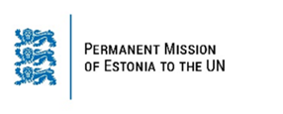 | 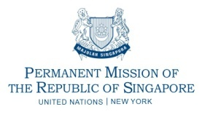

 | 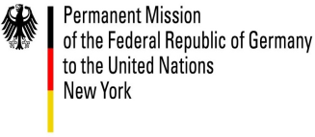 | 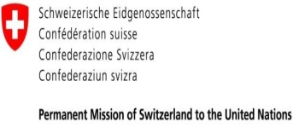

High-Level Side Event on
Cyber Security and International Cooperation
On Tuesday, 25 September 2018, 11.30 am – 1.00 pm
Conference Room 3, UNHQ

-Programme-

Security and Registration
10:30-11:20 hrs | 50 min | Security Checkpoint Arrivals and Check-in for delegates/guests
High-level Segment
11:30-12:00 hrs | 30 min | Welcome remarks by Ambassador Masud Bin Momen, Permanent Representative of Bangladesh to the United Nations in New York  - Statement by H. E. Sheikh Hasina, Prime Minister of Bangladesh  - Statement by H. E. Dr. Vivian Balakrishnan, Minister for Foreign Affairs of Singapore  - Statement by H. E. Mr. Paul Teesalu, Deputy Foreign Minister of Estonia  - Statement by H. E. Ms. Izumi Nakamitsu, Under-Secretary-General and High Representative for Disarmament Affairs, United Nations  - Statement by Mr. Masato Otaka, Ambassador in charge of Cyber Policy, Japan
Panel Discussion
12:00-12:25 hrs | 25 min | Panelists:  - H.E. Mr. Sajeeb Ahmed Wazed, Adviser to the Prime Minister on Information and Communication Technology Affairs, Government of Bangladesh  - Mr. Salem Avan, Director, Global Services Division, UN Office of Information and Communications Technology (UNOICT)  - Ms. Angela McKay, Senior Director, Cyber-security Strategy and Policy, Microsoft  - Ms. Eneken Tikk, Senior Advisor, ICT4Peace (Moderator)
Open Discussion
12:25-12:50 hrs | 25 min | - Interventions/ Comments from the floor
Closing Remarks
12:50-12:55 hrs | 05 min | - H. E. Dr. Tawfiq-e-Elahi Chowdhury, BB, Adviser to the Prime Minister on Power, Energy and Mineral Resources, Government of Bangladesh
Photo Session and Adjournment
12:55-1:00 hrs | 05 min

